**Aircraft Kinematic Tracking with Dynamic Gimbal Model**

Enson Su

AME 532a – Aircraft Stability and Control Final Report

Department of Aerospace and Mechanical Engineering

University of Southern California

Los Angeles, California

Table of Contents

Introduction 3

Background 4

Simulation Initial Conditions 4

Gimbal Definition 4

Nomenclature 5

Methods 6

Kinematics in Gimbal Aircraft’s Frame 6

Kinematics in Base’s Frame 7

Measurement system 7

Gimbal Dynamic Model 8

Gimbal Kinematic Model 9

Discretizing Lidar Distance measurements 10

Controller Model 11

Results 12

Desire Vs. True Gimbal Angles 12

Kinematic results from True and Referenced Gimbal Angles 14

# Introduction

Tracking another aerial object is an important task for many aircrafts’ missions as it provides useful kinematic information to the pilot, flight computer, and the base. In the case of human operating aircraft, visually tracking another aerial object is not reliable and not accurate enough to be useful for analysis. To provide kinematic information to the pilot and the base, a gimbal camera system is implemented in various aircraft to deliver useful and accurate information.

In this project, an idealized gimbal camera model with two axis of independent rotation is implemented with an ASW-28 glider model to report azimuth and theta angle of the other aerial object in the frame of ASW-28 FRD and base. The gimbal camera also has Lidar sensor installed to provide range measurement.

Through the gimbal camera’s output on azimuth, theta, and range measurement, the pilot will be able to quickly determine the location of the other aircraft with respect to himself. In addition, the onboard flight computer will be able to report the other aerial object’s position and velocity in the frame of the base.

# Background

## Simulation Initial Conditions

To present how gimbal measurements return azimuth, theta, and distance, the gimbal aircraft is place directly on top of LAX base with an altitude of 1000 meters, while the other aircraft of interest is place to the right of the gimbal aircraft with an altitude of 700 meters (i.e. slightly less longitude). Both aircraft models are a 6 DoF model developed throughout the semester. An initial velocity of 13 m/s and 0 rad/s body rate is applied to both aircraft. As a result, both aircraft will travel towards the North pole and oscillate in phugoid motion.

## Gimbal Definition

The gimbal system in the model is a fixed object attached to the aircraft with 2 independent rotating y and z axes, corresponding to pan and tilt angles. The x-axis of the gimbal is defined to be always pointing at the target of interest. Initially the coordinate system of the gimbal is the same as the aircraft’s FRD coordinate system, but as the gimbal changes its angle, there is a rotation matrix transformation between gimbal’s coordinate system and plane’s FRD coordinate system. The picture below illustrates the position of the gimbal relative to the aircraft’s center of mass.

## Nomenclature

: Definition of gimbal Lidar measurement

: Rate of change of target aircraft’s distance

: Target aircraft (B) with respect to gimbal (G) in gimbal’s frame

: Target aircraft (B) with respect to gimbal (G) in aircraft’s frame (O)

: Target aircraft (B) with respect to gimbal aircraft (O) in gimbal aircraft’s frame (O)

: Rotational matrix from gimbal to aircraft’s frame

: Rotational matrix from aircraft’s frame to NED frame (N)

: Velocity of gimbal aircraft with respect to NED in NED’s frame

: Gimbal tilt angle, measured from x-y plane of gimbal aircraft FRD to target aircraft

: Gimbal pan angle, measure from x-z plane of gimbal aircraft FRD to target aircraft

: Rate of change of and with respect to inertial frame (E)

: Body rate of gimbal aircraft

: Distance of gimbal with respect to reference point on gimbal aircraft in O frame

# Methods

## Kinematics in Gimbal Aircraft’s Frame

To find the kinematics information of the target aircraft in gimbal aircraft’s frame using purely readings from gimbal and Lidar measurement, a vector addition is used.

= (1.1)

Equation (1.1) relates gimbal reading and Lidar reading to represent target aircraft’s position with respect to gimbal in aircraft’s frame, and adding this result with , which is a constant value representing the position of the gimbal on the aircraft, it yields a position vector that the pilot can use intuitively to know the position of the other aircraft. The Rotation matrix is composed of a pitch and yaw matrix since gimbal only have two axes of rotation, and will change as target aircraft’s position changes, extracting the angles in the rotation matrix will give and , which is an intuitive representation of the other aircraft’s direction in pilot’s perspective.

Taking the derivative of (1.1) and applying Coriolis effect gives the velocity of target aircraft with respect to gimbal aircraft in gimbal aircraft’s frame.

(1.2)

## Kinematics in Base’s Frame

The base is chosen to be LAX using NED coordinate system, to get the position vector of the target aircraft using gimbal reading, the equation is now three vector’s addition, from base to gimbal aircraft, gimbal aircraft to gimbal, and gimbal to target aircraft.

= (2.1)

Taking the derivative of equation (2.1) and applying Coriolis yields

(2.2)

## Measurement system

With kinematics equations relating to gimbal, lidar measurement and gimbal aircraft’s kinematic information, the kinematic information of the other aircraft can be calculated; However, this kinematic equation does not consider gimbal dynamics and thus will be served as reference result, because gimbal has some inertia and will take some time to get to target values that depends on controller design. A measurement system needs to be constructed to provide target value to a dynamic gimbal model. The position of the target aircraft with respect to the gimbal in ECEF frame is given as the following.

(3.1)

Equation (3.1) performs vector subtraction from target aircraft position to gimbal position, both in ECEF frame. The resulting position vector is the target aircraft with respect to gimbal position in ECEF frame. Representing this in gimbal aircraft’s frame would be the following.

(3.2)

Equation (3.2) is an important piece of information in construction of the measurement system, since is in cartesian representation, converting it to spherical coordinate would directly give the azimuth, theta, and R value, and here the R value would be the magnitude of the position vector, analogues to Lidar measurement.

(3.3)

Equation (3.3) converts cartesian coordinates to spherical coordinates, psi is the azimuth angle, which is a z rotation measured from x-axis, thus psi is the panning angle for the gimbal camera. But theta is measured from the z-axis according to definition of spherical coordinate, thus psi is subtracted from pi/2 to give the angle measured from x-y plane of the aircraft’s FRD coordinate system, making theta the tilt angle.

(3.4a)

(3.4b)

## Gimbal Dynamic Model

With and obtained from the measurement system, a dynamic gimbal model that uses those two values as target is now achievable. An idealized gimbal camera dynamic model is built in collaboration with Faheem Chunara, and with the following assumptions. The moment of inertial matrix is symmetrical, and the gimbal camera has no saturation zone. Below is the block diagram of the gimbal camera system including measurement system.

*Figure 1: gimbal camera system block diagram*

The dynamics block takes external torque as an input to the system and outputs body rate of the gimbal using the following equation derived from Newton 2nd law.

(4.1)

Integration of equation (4.1) yields the true body rate of the gimbal camera, which is affected by the inertial matrix . Note that if is 0 or insignificant, the true gimbal body rate closely matches the desired gimbal rate that comes from taking the time derivative of desired gimbal angle.

## Gimbal Kinematic Model

True gimbal rate is pass into the kinematic block that determines the angular displacement of the gimbal using quaternion method, the resulting gimbal pan, and tilt angle is used to construct which then is multiplied with , giving body rate in gimbal’s frame, together with that comes from rotational dynamics, can be constructed to yield results for equation (1.1), (1.2), (2.1), (2.2). Simulink diagram below shows the quaternion method in rotational kinematics.

*Figure 2 : quaternion approach for rotational kinematics*

## Discretizing Lidar Distance measurements

To add another level of fidelity, a discretization of the distance measurement is took into account. Between the time when gimbal is moving towards the target, the Lidar measurement should not have returned any reading because there is no physical surface for light wave reflection. To account for this in the model, a simple discretizing block is added to the gimbal system. Since desire gimbal angle is coming from the measurement block and true gimbal angle is produced through gimbal kinematics, the difference between those angles quantitatively describes how much angle variance until the gimbal points at the other aircraft. Thus, range measurement is is only allowed to pass value when both true pan and tilt angle are within 5% error about desire pan and tilt angle.

*Figure 3: Discretization Block Diagram*

## Controller Model

The controller in figure 1 is responsible for adjusting the input moment to the gimbal system, it compares true gimbal angles with desire gimbal angles and outputs a torque to the gimbal dynamics model. Each axis has an independent PID controller that provides moment individually, and the gains is adjusted using Simulink PID tuner.

*Figure 4: Gimbal PID Controller*

# Results

## Desire Vs. True Gimbal Angles

Desire and gimbal angle’s major distinction is that one accounts for dynamics of gimbal system while the other simply outputs an instantaneous angle of the target aircraft. This plot below shows how desire gimbal system outputs pan and tilt angle, converging to ~ -41.9 and ~ 86. Which

*Figure 5: Desire pan and tilt angle ()*

With controller implementation, the true gimbal angle is the following plot, converging to ~ -41.9 in theta and ~ 87 degrees in psi. In the perspective of the pilot, the target aircraft is to the right and below.

*Figure 6: True pan and tilt angles*

## Kinematic results from True and Referenced Gimbal Angles

Recall that the measurement system outputs the desire gimbal angle that is becomes the set point for the controller, but those values can be used to compute target aircraft’s kinematic information with the following block that follows equation (1.1) through (2.2)

*Figure 7: equation (1.1) through (2.2) calculation block*

The following four plots are the referenced kinematic information of the target aircraft in the frame of gimbal aircraft(O), and the base (N).

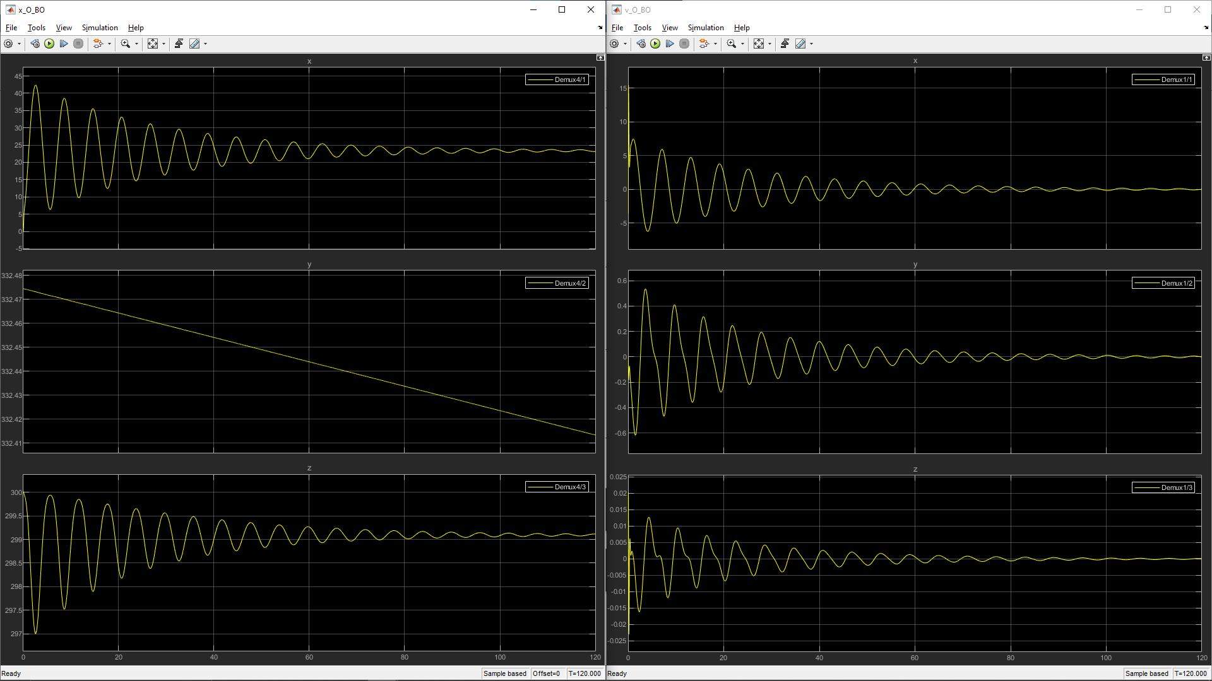

*Figure 8: x_O_BO (Left) and v_O_BO (Right)*

*Figure 9: x_N_BN (Left) and v_N_BN (Right)*

The kinematic information of target aircraft accounting for gimbal dynamics, controller, discretization of Lidar produces the following plots for gimbal aircraft (O) and base (N) frame.

*Figure 10: True x_O_BO (Left) and True v_O_BO (Right)*

*Figure 11: True x_N_BN (Left) and True v_N_BN (Right)*

The cut off of signal at the beginning of the kinematic plots is due to the discretization of the system, because there the controller produces some overshoot over set point value, there is a lost of information when the gimbal points at an empty space; however, as time goes on and both aircraft reaches steady state, the gimbal is able to maintain constant tracking on the target as there were no signal cut off.

Overall, the difference between referenced kinematic and true kinematics is insignificant as system settles, but there are large variance in the beginning when there were no readings from the Lidar, or when true gimbal angle is overshooting/settling. Further tunning the PID controller will improve the result and provide more stable reading. In the case when two aircrafts are too far apart from each other, there is a higher demand for accuracy of the controller as there are less surface reflection for Lidar, so the gain in the controller is distance-varying, but for simplicity the gain is constant since distance of the two aircraft do not vary much in this simulation.

# Conclusion

This project is an amazing opportunity for me and my team to get familiar with how to handle a coupled dynamical system and extracting practical information that can be used for further analysis. I learned and practiced derivation of kinematic equation accounting for two Coriolis effect, which is gimbal and aircraft’s rotation, and implementing those equations into a block that takes input from the gimbal system. In addition, a gimbal camera is a dynamical system that has physical properties that must be considered when trying to control it, and changing its J-matrix can affect its accuracy and speed. The Lidar sensor on the camera works by detecting light waves that bounce back from surfaces, so making them discrete can further simulate the accuracy of the kinematic results.